EASTERN INTERNATIONAL UNIVERSITY
SCHOOL OF COMPUTING AND INFORMATION TECHNOLOGY
DEPARTMENT OF SOFTWARE ENGINEER



PROJECT 2 REPORT
LEILA E-COMMERCE WEBSITE

Student(s)
Trần Hải Việt - 2031200032
Lê Châu Quang - 1931200026

Supervisors
Ph.D Phạm Đại Xuân
Binh Duong, June, 2024

ABSTRACT
The project aims to create a website that aims to sell products such as clothes, necklaces, hats, ... to customers. The website will provide a user-friendly interface where customers can choose from a variety of products, view product details and pricing details, and make secure online transactions to purchase products. their desired product. It will be designed to meet the needs and preferences of different customers by offering a variety of brands, models and price points. The project will leverage the potential of e-commerce to provide a convenient and efficient platform for customers to purchase apparel and accessories from the comfort of their own homes. Through comprehensive marketing strategies and effective customer service, the website aims to attract and retain a large customer base and ultimately become a trusted and reliable online platform for shopping for consumers.

ACKNOWLEDGEMENTS
First of all, we would like to thank the Management Board of the School of Information Technology for facilitating us to do this topic.
In particular, we would like to thank Mr. Pham Dai Xuan for his whole hearted help and guidance from the conception of the idea to the completion of the project.
Through the process of researching and doing topics, we have learned a lot of usefulness, know how to plan and arrange work scientifically and effectively. We hope that what we have learned in the process of working on this topic will help us consolidate our knowledge and be the first baggage for us to achieve the best steps for the future.

Table of Contents
ABSTRACT 2
ACKNOWLEDGEMENTS 3
LIST OF FIGURES 7
LIST OF ABBREVIATIONS 10
Chapter I. Introduction 11
1.1 Motivation 11
1.2 Objectives 11
1.3 Project Overview 12
CHAPTER II. Related Works 13
2.1 React 13
2.1.1 React Introduction 13
2.1.2 Advantages and Disadvantages of React 13
2.2 Node.js 14
2.2.1 Node.js Introduction 14
2.2.2 Advantages and Disadvantages of Node.js 14
2.3 HTML 15
2.3.1 HTML introduction 15
2.3.2 Advantages and Disadvantages of HTML 15
2.3 Tailwind CSS 16
2.3.1 TailwindCSS Introduction 16
2.3.2 Advantages and Disadvantages of TailwindCSS 16
2.4 MongoDB 18
2.4.1 MongoDB introduction 18
2.4.2 Advantages and Disadvantages of MongoDB 18
2.5 Express.js 19
2.5.1 Express.js introduction 19
2.5.2 Advantages and Disadvantages of Express.js 19
2.6 Next.js 20
2.6.1 Next.js introduction 20
2.6.2 Advantages and Disadvantages of Next.js 20
CHAPTER III. Analysis, Design and Implementation 22
3.1 Requirement Analysis 22
3.1.1 Login and Logout function 22
3.1.2 Register a new account 22
3.1.3 Password functions 22
3.1.4 Showing profile of user 22
3.1.5 Showing products 23
3.1.6 Showing products detail 23
3.1.7 Cart functions 23
3.1.8 Showing Dash Board 24
3.1.9 Functions in Dash Board 24
3.1.10 Use Case Diagram: 25
3.2 Interface Design 26
3.3 Database Design 37
3.4 Implementation 42
3.4.1 Development environment 42
3.4.2 Implementation 42
Chapter IV. Result and Discussion 49
Chapter V. Conclusion and Future Works 50
5.1 Conclusion 50
5.2 Future Works 50
REFERENCES 51

LIST OF FIGURES
Figure 1. Use Case Diagram for Online Shopping Syste 25
Figure 2. Dashboard Design 27
Figure 3. Add or Edit Product Page 28
Figure 4. Product Dashboard Page 29
Figure 5. Add or Edit Collection 30
Figure 6. Collection Dashboard Page 31
Figure 7. Order Dashboard Page 32
Figure 8. Customer Dashboard Page 33
Figure 9. E-commerce Shopping Homepage 34
Figure 10. Product Detail Page 35
Figure 11. Wishlist Page 36
Figure 12. Order Page 37
Figure 13. Cart Page 38
Figure 14. Collections table 39
Figure 15. Product table 40
Figure 16. User table 41
Figure 17. Order table 41
Figure 18. Customer table 42
Figure 19. Database diagram 42
Figure 20. Login page for admin 43
Figure 21. Wrong password warning 44
Figure 22. Admin Dashboard 45
Figure 23. Add or Edit Product 46
Figure 24. Collection Page 46
Figure 25. Order Page 47
Figure 26. Customer Page 47
Figure 27. Collection and Product Section 48
Figure 28. Cart Page 48
Figure 29. Payment Page 49

LIST OF TABLES
Table 1. Pros and Cons of React 13

LIST OF ABBREVIATIONS
No | Abbreviation | Definition
1 | JS | JavaScript
2 | HTML | Hyper Text Mark Languages
3 | NPM | Node Package Manager
4 | I/O | Input/Output
5 | UI | User Interface
6 | JSX | JavaScript XML
7 | SQL | Structured Query Language
8 | NoSQL | Not Only SQL
9 | ACID | Atomicity, Consistency, Isolation, and Durability

Chapter I. Introduction

Motivation
Nowadays, information technology is developing strongly, the Internet is widely available, and the demand for online shopping is increasing, so shopping is no longer strange to everyone. Although building an online shopping website in our country is still new, it is very feasible as the country is gradually innovating and developing. This is also a huge opportunity for e-commerce in Vietnam to develop.
The topic "Building an online shopping and introduction website" is very practical and suitable for the current situation. Setting up an online shopping website quickly with many utilities and completely free can promote the shop's image, create convenient opportunities for everyone, save time and be completely convenient for everyone.
This can be considered the optimal and practical solution for shopping via websites in our country today.

1.2 Objectives
- Create and deploy a customer-friendly shopping website that provides a seamless and easy-to-use interface.
- Deploy a reliable and effective user authentication mechanism to protect user information and ensure privacy.
- To provide an expanded search feature that allows customers to search for products according to their preferences and other appropriate parameters.
- Develop a shopping system and allow customers to purchase products of their choice and receive confirmation through payment by bank card.
- Provides a reliable MongoDB database management system to store and manage user profiles, product invoice information that customers transact with the shop, and product details.
- Create dynamic and responsive front-end and back-end architecture with React and Node.js, Next.js enables real-time updates and interactions.
- Improve user engagement and satisfaction by streamlining site performance and load times

1.3 Project Overview
In this project, React, Node.js and MongoDB, Next.js are used to build a website about shopping via website. The user interface components will be built using the famous React JavaScript package, ensuring a fluid and engaging user experience. The server-side runtime environment, Node.js, will handle the server-side logic and enable smooth front-end and back-end interactions. Product data, user data, and orders details will all be stored in MongoDB, a NoSQL database.

CHAPTER II. Related Works

2.1 React

2.1.1 React Introduction
React is the most popular JavaScript library for building user interfaces (UIs). It gives excellent response speed when the user enters data using the new method to render the web page. The components of this tool are developed by Facebook. It was launched as an open-source JavaScript engine in 2013.

2.1.2 Advantages and Disadvantages of React
React Pros | React Cons
1. High Performance: Using Virtual DOM optimizes performance and minimizes impact on the actual DOM. | 1. Requires time to understand and master concepts such as JSX, Virtual DOM, and state.
2. Reusable Component: High reusability, which reduces code repetition and increases maintenance. | 2. Initial Configuration Overhead: Requires installation and configuration of the development environment, which can be extra time-consuming.
3. Robust Library: There is a large community and many third-party libraries that support it. | 3. Can be complicated for small applications: Sometimes there are too many features for simple applications.
4. JSX: Using JSX helps make the source code clear and easy to read. | 4. User Interface Management Only: React mainly focuses on the user interface, so you need to add another library or framework to handle other tasks such as routing.
5. Strong Community Support: The community is large and active, offering many resources and solutions. | 5. Dynamic data is difficult to manage: State management for large applications can get complicated.
6. React Native: The ability to share code between a web app and a mobile app through React Native. | 6. Versions that change quickly: New versions can make changes quickly, requiring constant updates.
7. Big Company Support: Supported by Facebook and widely used in their projects. | 7. Using JSX Can Confuse Beginners: Combining HTML with JavaScript can make JSX difficult for beginners to read.
Table 1. Pros and Cons of React

2.2 Node.js

2.2.1 Node.js Introduction
Node.js is a software system designed to write scalable internet applications, especially web servers. The program is written in JavaScript, using event-driven, asynchronous import/export techniques to minimize total cost and maximize scalability.

2.2.2 Advantages and Disadvantages of Node.js
The advantages of Node.js:
- Fast processing speed thanks to the asynchronous processing mechanism (non-blocking). You can easily handle thousands of connections in the shortest amount of time.
- Make it easy for you to expand when you need website development.
- Receive and handle multiple connections with just one single-thread. As a result, the processing system will use the least amount of RAM and make the processing of Node.js much faster.
- Ability to handle multiple Requests / s at the same time in the shortest time.
- Capable of handling thousands of processes for the most optimal performance.
- Suitable for building real-time applications such as chat applications, social networks
The disadvantages of Node.js:
- Node.js is resource and time consuming. Node.js is written in C++ and JavaScript, so processing needs to go through a compilation process. If you need to handle applications that consume CPU resources, you should not use Node.js.
- Node.js compared to other languages like PHP, Ruby, and Python will not have too much difference. Node.js will probably be suitable for new application development. However, when building and implementing important projects, Node.js is not the perfect choice.

2.3 HTML

2.3.1 HTML introduction
HTML is a markup language designed to create web pages on the World Wide Web. It can be helped by technologies like CSS and scripting languages like JavaScript

2.3.2 Advantages and Disadvantages of HTML
Advantages of HTML:
- Simple and easy to learn: HTML is a simple, easy-to-learn language, so users can -start learning and using it quickly.
- High compatibility: HTML is designed to be compatible with multiple web browsers, making it easy for users to access websites on many different devices.
- Multilingual support. HTML supports many different languages, allowing users to create multilingual websites.
- Compatibility with other web technologies: HTML can integrate with other web technologies such as CSS and JavaScript to create professional-looking web pages.
- Good support for SEO: HTML is used to define the structure of the website, helping search engines like Google, Bing, Yahoo ... Can easily understand and evaluate the content of the website, thereby increasing the chances of ranking high in search results.
Disadvantages of HTML:
- Can't handle complex logic: HTML is just a markup language for the structure and content of a web page; It cannot handle complex logic like programming languages, so cannot create dynamic and complex web applications.
- Ability to create simple web pages: HTML has no special features for creating dynamic web pages, so web pages are just simple and basic.
- Low security: HTML does not have built-in security features to protect websites from attacks and vulnerabilities. Website security depends on other technologies such as SSL, HTTPS, or CMS content management systems.
- Difficulty in managing large websites: As websites become large and complex, managing HTML code becomes very difficult, hence the need to use content management tools and database management systems.
- Potential for errors and not displaying properly on different devices: HTML does not guarantee that web pages will display properly on all devices. This can lead to compatibility related issues across different platforms and devices.
- However, the above disadvantages can be overcome by using other technologies such as CSS, JavaScript, or CMS content management systems to create professional and effective websites.

2.3 Tailwind CSS

2.3.1 TailwindCSS Introduction
It is a utility-first CSS framework, just like Bootstrap, it has built-in classes that we can use. Tailwind CSS has many classes that include different and important CSS properties, we can easily expand and create new classes using its own classes.

2.3.2 Advantages and Disadvantages of TailwindCSS
Advantages of TailwindCSS:
- Speed ​​Up Development: Use utility classes: Tailwind CSS provides hundreds of compact utility classes, helping you build complex interfaces quickly without writing CSS from scratch.
- Intuitive design: You can instantly see the results of changes while writing HTML, making design more intuitive.
- Easy to Maintain and Extend: No need for custom class names: By using utility classes, you don't need to name separate CSS classes, which helps minimize name conflicts and makes CSS code easier to read and understand than.
- Highly Responsive: Responsive class: Tailwind CSS provides responsive utility classes, making it easier to design user interfaces for mobile devices.
- Highly Customizable: Tailwind CSS has a powerful configuration file that allows you to customize design values ​​such as colors, spacing, fonts, and more.
- JIT (Just-In-Time) Compilation support: JIT version of Tailwind CSS helps speed up build and reduce final CSS file size.
- Highly Customizable: Tailwind CSS has a powerful configuration file that allows you to customize design values ​​such as colors, spacing, fonts, and more.
-Easy Reuse: Utility classes can be reused across the entire project, making project maintenance and extension easier.
Disadvantages of TailwindCSS:
- Large Volumes of HTML: Multiple widget classes: Using multiple widget classes can make the HTML code cumbersome and difficult to read, especially for complex interfaces.
- Unclear: HTML code may become less clear, especially for those new or unfamiliar with Tailwind CSS.
- Missing widget classes: Sometimes, you need to create a custom widget class when the available widget classes do not meet your needs, resulting in the need to write additional custom CSS.
- Uniform design: Due to the use of utility classes, the look and feel of projects using Tailwind CSS can become similar, leading to a lack of individuality and creativity.
- Large CSS Files If not configured properly, Tailwind CSS can generate very large CSS files due to the number of utility classes, although this can be minimized by using PurgeCSS or the JIT compilation feature.

2.4 MongoDB

2.4.1 MongoDB introduction
MongoDB is a cross-platform opensource NoSQL database management system written in C++. The record in MongoDB is stored as a text data, which is a data structure consisting of value pairs and fields similar to JSON objects.

2.4.2 Advantages and Disadvantages of MongoDB
Advantages of MongoDB:
- Document oriented
- High performance
- High availability – Scaling
- Highly Scalable – Sharding
- Dynamic – No rigid schema.
- Flexible – add/remove fields with little or no impact on the application
- Heterogeneous data
- Deliverable
- Data representation in JSON
- Geospatial support
- Easy integration with Hadoop BigData
- Powerful document-based query languages like SQL Cloud distributions such as AWS, Microsoft, RedHat, dotCloud and SoftLayer, etc. In fact, MongoDB is built for the cloud. Its natural scaling architecture, enabled by sharding, aligns well with the scale and agility afforded by cloud computing.
Disadvantages of MongoDB:
- One downside of NoSQL is that most solutions do not comply with ACID as strongly (Atomic, Consistency, Isolation, Durability) as better established RDBMS systems.
- Complex transactions
- No stored function or procedure exists where you can bind logic
It's crucial to remember that MongoDB's usefulness varies depending on the particular use case and application needs. Even though it has benefits in terms of flexibility and scalability, it might not be the best option for all projects, especially ones that call for deep relational data structures, complicated joins, or rigorous consistency. It is crucial to give these elements careful thought when selecting MongoDB, or any other database technology, for your application.

2.5 Express.js

2.5.1 Express.js introduction
Translated from Anh-Express.js, or simply Express, is a back-end web application framework for building RESTful APIs with Node.js, released as free and open source software under the MIT License. It is designed to build web applications and APIs. It has been called the de facto standard server framework for Node.js.

2.5.2 Advantages and Disadvantages of Express.js
The advantages of Express.js:
- Simple and easy to use: Express.js has a simple and easy-to-understand syntax, making it easy for programmers to grasp and implement features.
- Flexible: Express.js does not impose a specific structure, giving programmers the freedom to customize and build the application as they like.
- Middleware support: Express.js provides a powerful middleware system, allowing to perform functions such as authentication, logging, data compression and error handling flexibly and easily.
- High performance: Express.js is built on Node.js, high-performance platform, allowing for quick processing of simultaneous and well-scalable web requests.
The disadvantages of Express.js:
- Lack of structure: Since Express.js does not impose a strict structure, project organization and source code management can become difficult, especially when the application grows large and complex.
- Scalability: As the application grows large and complex, managing source code and scaling can become difficult with Express.js. Careful control is required to avoid complexity and confusion in managing modules and interactions between them.
- Support Community: Although Express.js has a large and well-documented community, however, does not achieve the same level of support as other web frameworks like Angular or React

2.6 Next.js

2.6.1 Next.js introduction
Next.js is an open source framework built on the foundation of React, allowing us to build super-fast and user-friendly static websites, as well as build React web applications.

2.6.2 Advantages and Disadvantages of Next.js
Advantages of Next.js:
- Server-Side Rendering (SSR - Server-Side Rendering): Improved SEO: Server-side rendering websites can be indexed by search engines more easily. Increase page loading speed: Users can see the content Page content is faster because the HTML is pre-rendered on the server.
- Static Site Generation (SSG): High performance: Static pages are generated during the build process and can be served via CDN, increasing page load speed.
- API Routes: Serverless functions: Next.js allows you to create API routes, making it easy to deploy serverless endpoints without the need for a separate server.
- High performance: Express.js is built on Node.js, high-performance platform, allowing for quick processing of simultaneous and well-scalable web requests
- TypeScript Support: Next.js has TypeScript support out of the box, making development safer and more efficient.
Disadvantages of Next.js:
- Initial Complexity: Complex Configuration: For newcomers, the initial configuration of Next.js can be more complicated than using other frameworks like Create React App.
- Project Size: For small applications, using Next.js can become redundant and unnecessarily increase project size.
- Server Dependent:High cost: With SSR features, you may have to maintain a server, leading to higher hosting costs compared to static websites.
- Takes time to get used to: Next.js has many powerful features such as SSR, SSG, ISR (Incremental Static Regeneration), and API routes. Learning how to take full advantage of these features can take a lot of time and effort.
- Community and Support Documentation: Compared to other frameworks like React or Angular, Next.js's community and support documentation may not be as extensive, although this is changing rapidly.

CHAPTER III. Analysis, Design and Implementation

Requirement Analysis

3.1.1 Login and Logout function
The login form on the login page provides the server with the username and password for this function. The user is then retrieved from the database using the username that was supplied, and the password's accuracy is confirmed. When a user is classified as "admin," the system takes them to the Dashboard Page; if not, it takes them to the Home Page ^{[1]}.

3.1.2 Register a new account
The User object from the registration form is received by the server, which processes information such the user type, password, and username. Ensuring strong password encryption through the use of Google and Facebook login enhances system security in general. The user type, "user," which denotes a standard user account, will be set if a user registers using the Registration Page. In addition, the user type will be set to "admin" if registration is done via the Dashboard. After then, the server keeps user data in the database permanently. After that, the user is sent to the Login Page, where they may easily finish the registration process ^{[1]}.

3.1.3 Password functions
The server manages a user's password recovery in this function. It clicks on a given URL to obtain a new password and a token. The server updates the user's password after securely encrypting it and uses the token to identify the matching user. The user's password is successfully reset and updated in the system thanks to this safe procedure ^{[1]}.

3.1.4 Showing profile of user
In order to show data on the Profile Page, the server receives the User object from the session during this procedure. The server sends the user to the Login Page to make sure they have completed the necessary authentication steps before they can access the Profile Page if the User object is null, which indicates that they are not logged in or authenticated ^{[2]}.

3.1.5 Showing products
In order to guarantee correct authentication before allowing access to the Profile Page, the server reroutes the user to the Login Page if the User object is null, indicating that the user is not authorized or logged in ^{[2][3]}.

3.1.6 Showing products detail
The purpose of the feature is to provide comprehensive product information on a specific product details page. To obtain the relevant product from the database, it takes the product name as an input. The function then returns the view name "productDetail" for showing the product details page when the obtained product has been added to the model^{[6][9]}.

3.1.7 Cart functions
- Add to cart function: The process of adding items to the user's shopping cart is managed by this function. It gets the amount, the product ID, and the user's session data. After the user's authentication has been verified, the associated user's cart is either generated or retrieved. The chosen item is subsequently added to the cart, and the amount is adjusted if it is already there. The cart's total cost is computed, and the modifications are stored in the database ^{[4][8]}.
- Remove cart item: The removal of a particular item from the user's shopping cart is handled by this function. It tries to get the related “Cart” from the service using the item's ID as a parameter. The procedure then deducts the final price of the eliminated item from the linked order's total price. The item is deleted from the database by calling the “Cart(id)” function. The related order is likewise erased if the removal leaves the cart empty ^{[7][2]}.
- Clear cart function: The removal of the user's cart is handled by this function. After removing the user from the session, it uses the `Cart` function to obtain the associated cart, which is Order.
- Update cart function: The updating of the items in the user's shopping cart is handled by this function. It is provided with data on the goods and quantities that need to be updated. Every item in the data is iterated over, the amounts are changed, and the associated “Cart” are updated. The “Cart” is removed in the event that the quantity is 0. After that, the order's total is reassessed, and if the cart is empty, the order is cancelled in its entirety.
- Checkout function: When a user approves their order, this function takes care of the checkout procedure. It gets a number of parameters, including user data, product names, amounts, and order IDs. After that, the procedure iterates over the chosen goods, modifies their amounts, and generates the relevant “Checkout”. Next, before being saved, the Order object is updated with the user's data, status, and creation timestamp ^{[2][5]}.

3.1.8 Showing Dash Board
Every method uses information from the appropriate services to fill the model with information relevant to the corresponding page (users, brands, items, orders, contacts, etc.). The HTML template that will be shown for every admin page is specified in the return statement. Verify that the HTML templates are present and set up correctly ^{[7]}.

3.1.9 Functions in Dash Board
- Save and Edit user: In order to enable two-way data binding between the HTML form and the server-side model, this form binds to the "saveUser" object using "Clerk". Input options for login, password, complete name, birthdate, phone number, email address, address, and user type are all included. There is a toggle in the password box to show or conceal the password that has been entered. In addition, the form offers a drop-down menu where users may pick between the options "User" and "Administrator." Additionally, there are options on the form to submit changes and cancel operations, which takes users to the admin page where they may manage users ^{[4][9]}.
- Save and Edit brand: The "post" method and "saveBrand" action attribute are set on the form. A file for uploading brand pictures that have been stylized with the "Cloudinary" library is included. There is a text entry field on the form where the brand name may be entered. When the form is submitted, the associated brand name and picture are sent together with the data input to the "saveBrand" endpoint. The form further features buttons for saving data and canceling processes, each of which has an associated action ^{[4][9]}.

- Save and Edit product: The form is set up to handle product data, including image, name, brand, price, quantity, discount, summary, and product description. It employs "Cloudinary" characteristics to correlate content dynamically. It has many text input fields, drop-down menus for choosing brands, and file input for uploading product photos using the "Cloundinary" plugin and the "Shadcn" library. The form is divided into three sections: the first lets the administrator upload or edit product photographs; the second takes in data on the fundamental specifications of the product; and the third section addresses include fields for the description and summary. With buttons to save or cancel the process, the form makes a POST request to the "saveProduct" endpoint when it is submitted^{[8][4]}.

3.1.10 Use Case Diagram:
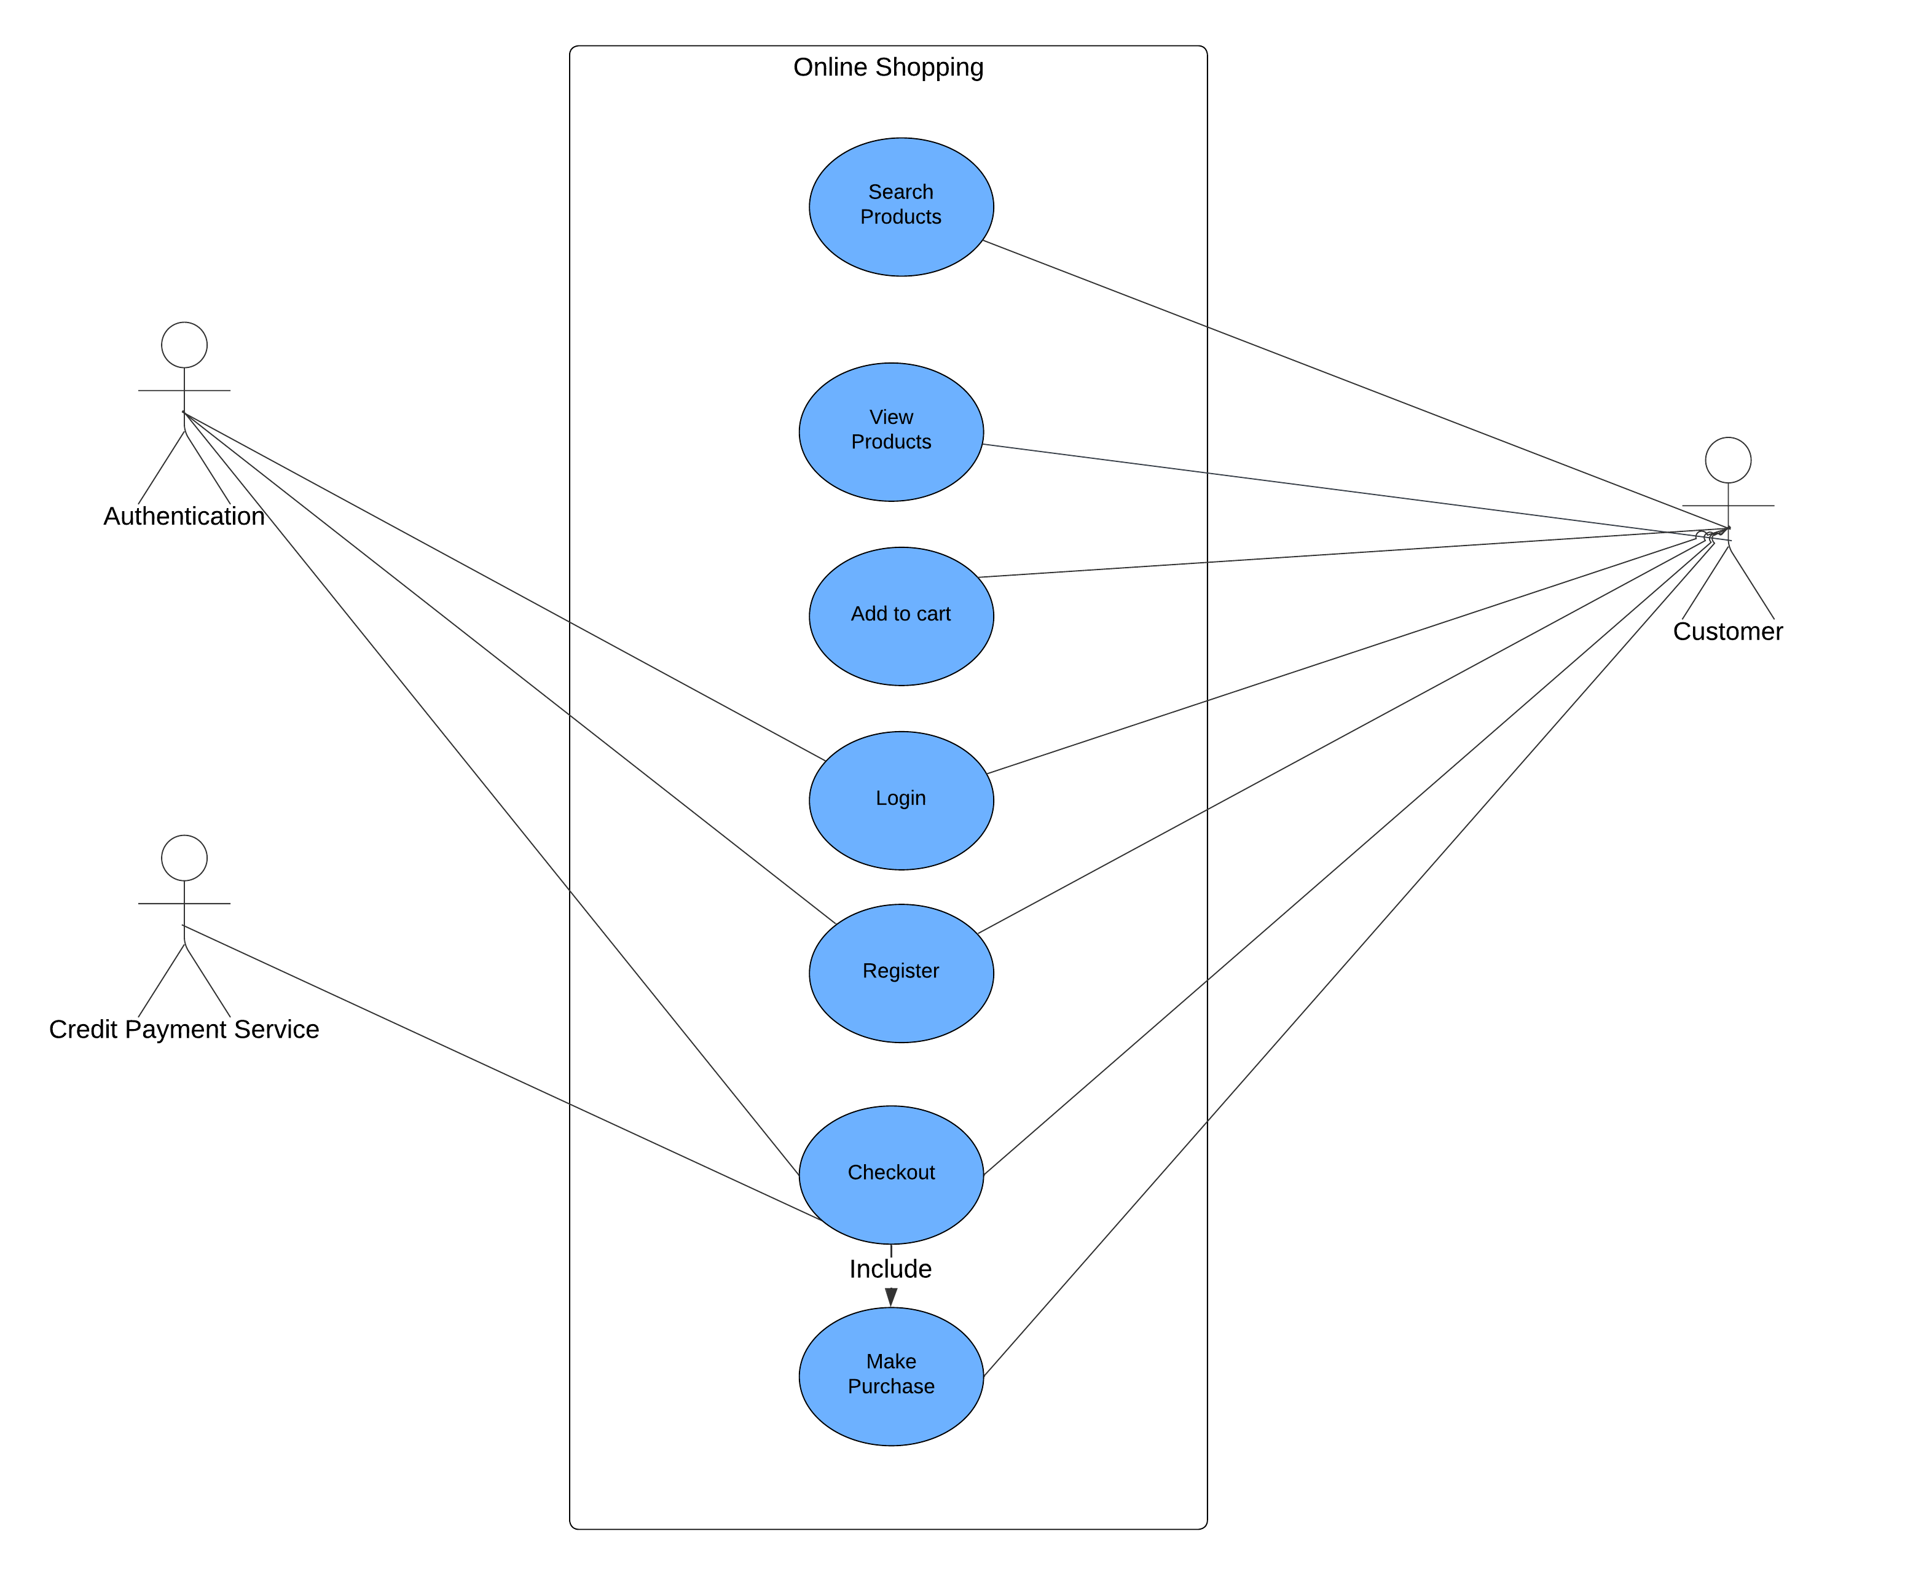
Figure 1. Use Case Diagram for Online Shopping Syste
This Use Case Diagram is used to represent the interaction between actors and the system itself of an e-commerce website. The primary actor is “Customer” can perform various actions including searching products, viewing products, adding items to cart, registering account, logging in and proceeding to checkout. The “Checkout” process includes “Make Purchase” process which involve Credit Payment Service to handle transactions. The Authorization actor is responsible for managing registration, user login, and managing checkout process through webhooks. The fundamental functions of the online shopping platform are clearly mapped out in this diagram, which also demonstrates how various parts interact to provide a seamless shopping experience.

3.2 Interface Design
In this subsection, we will show the sketches of our application's interface, including the login page, homepage, dashboard, product details page, wishlist page, cart, checkout page.
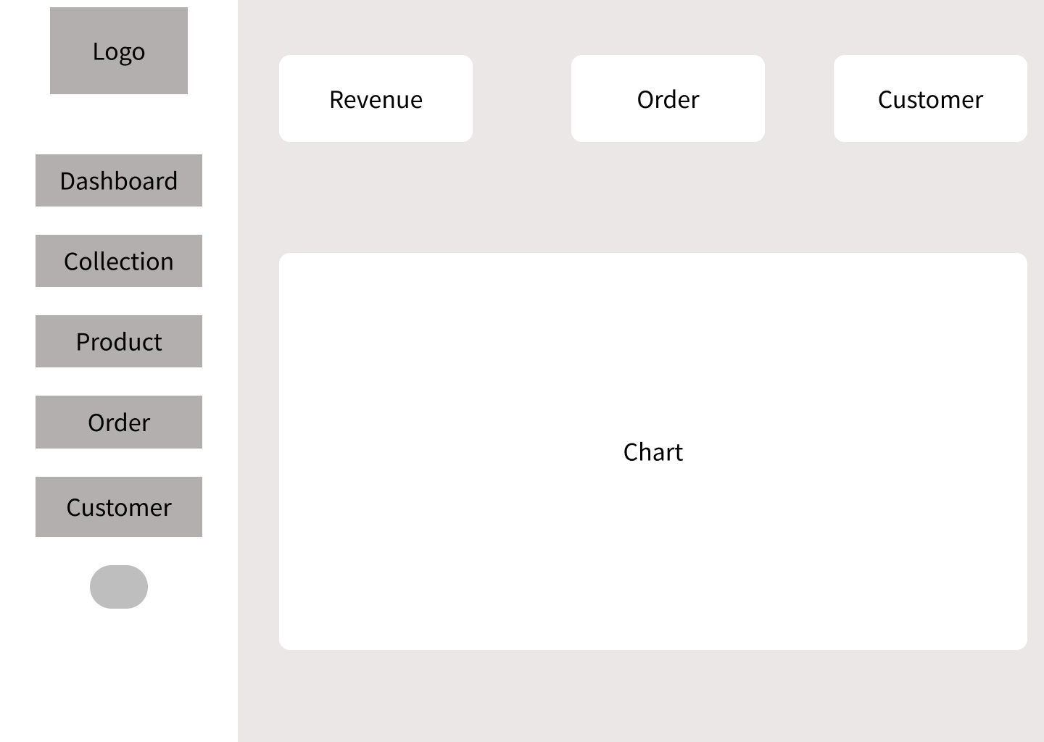
Figure 2. Dashboard Design
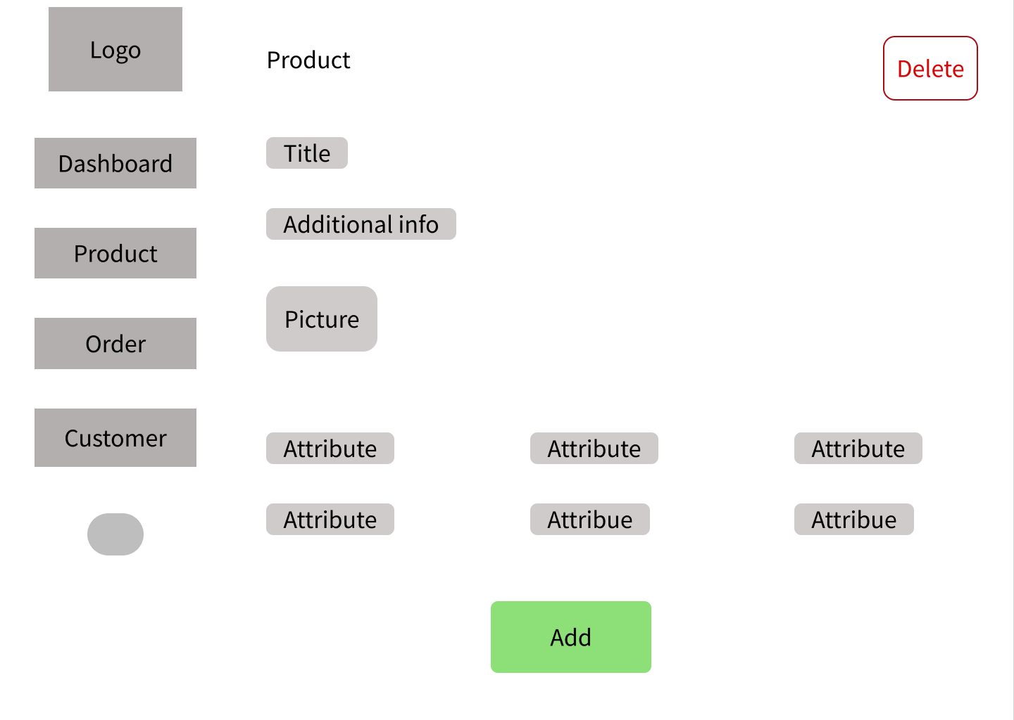
Figure 3. Add or Edit Product Page

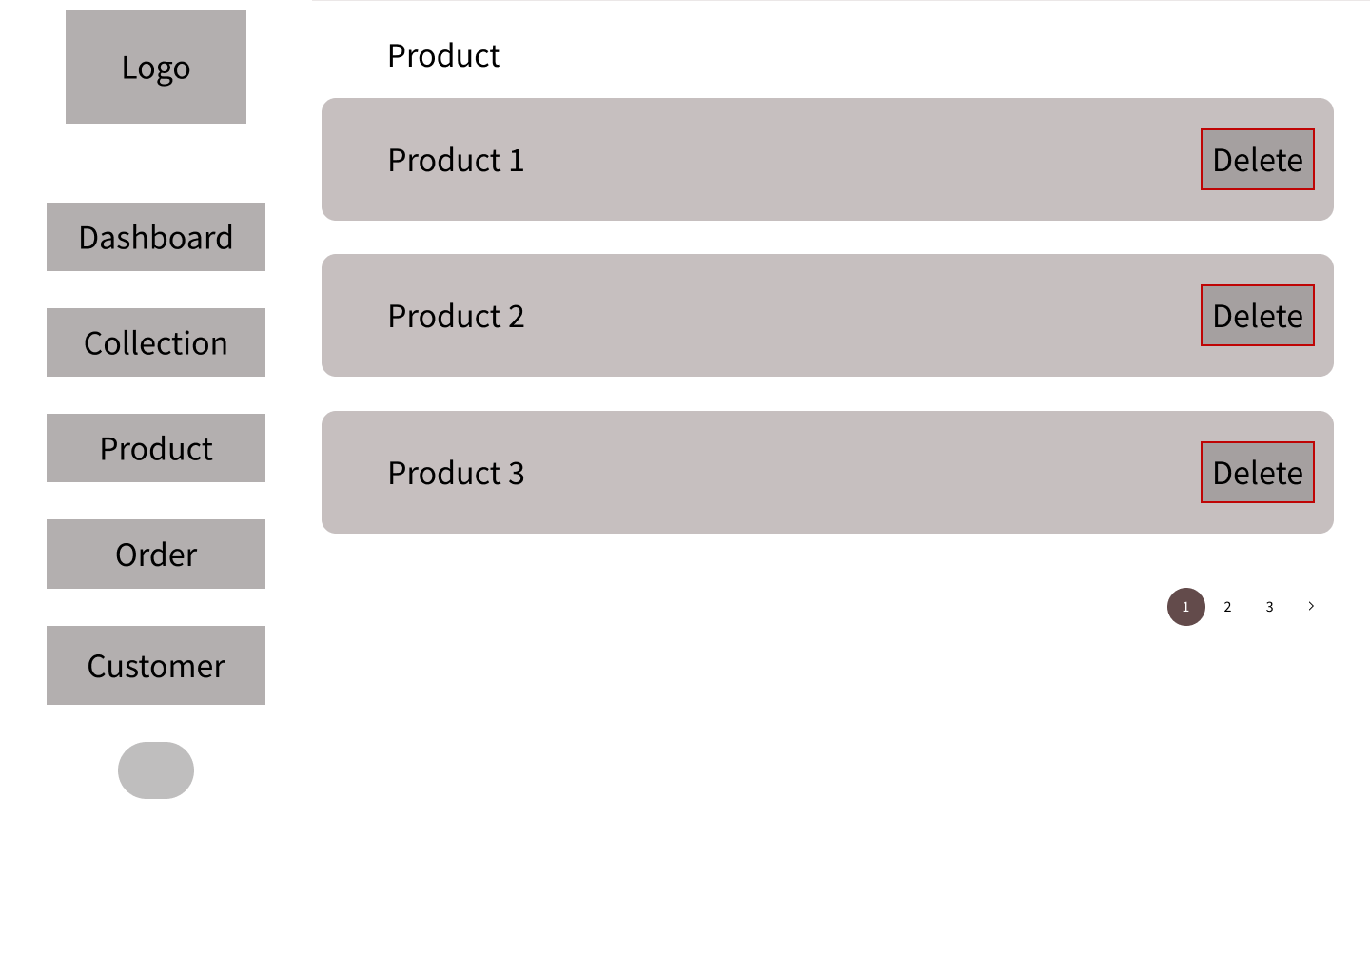
Figure 4. Product Dashboard Page
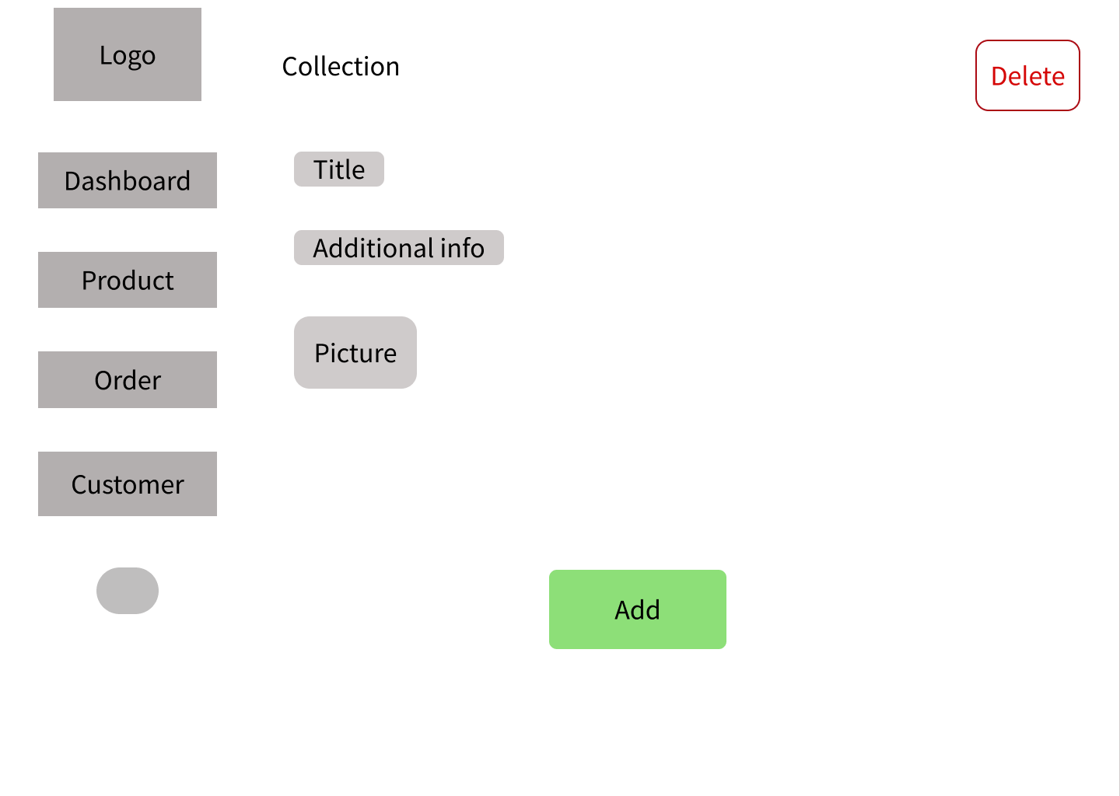
Figure 5. Add or Edit Collection

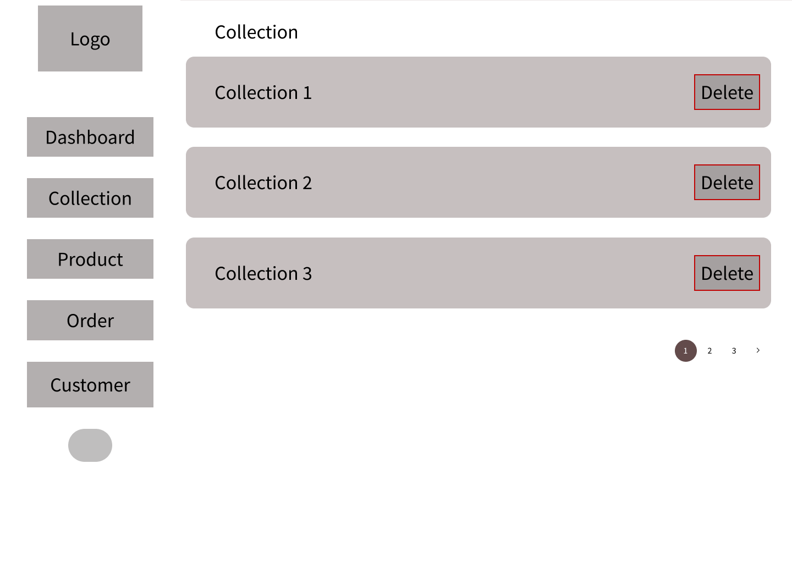
Figure 6. Collection Dashboard Page

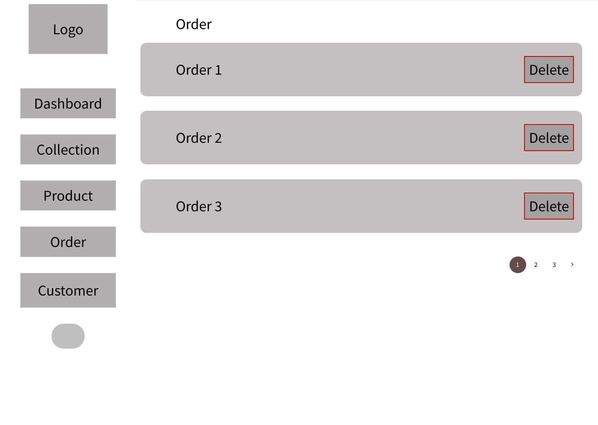
Figure 7. Order Dashboard Page

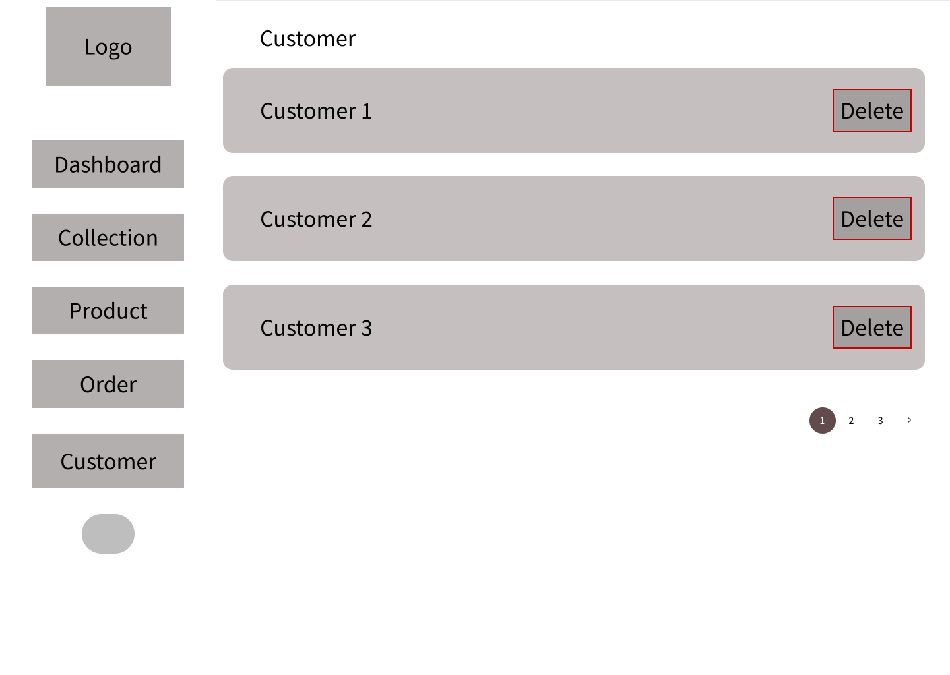
Figure 8. Customer Dashboard Page

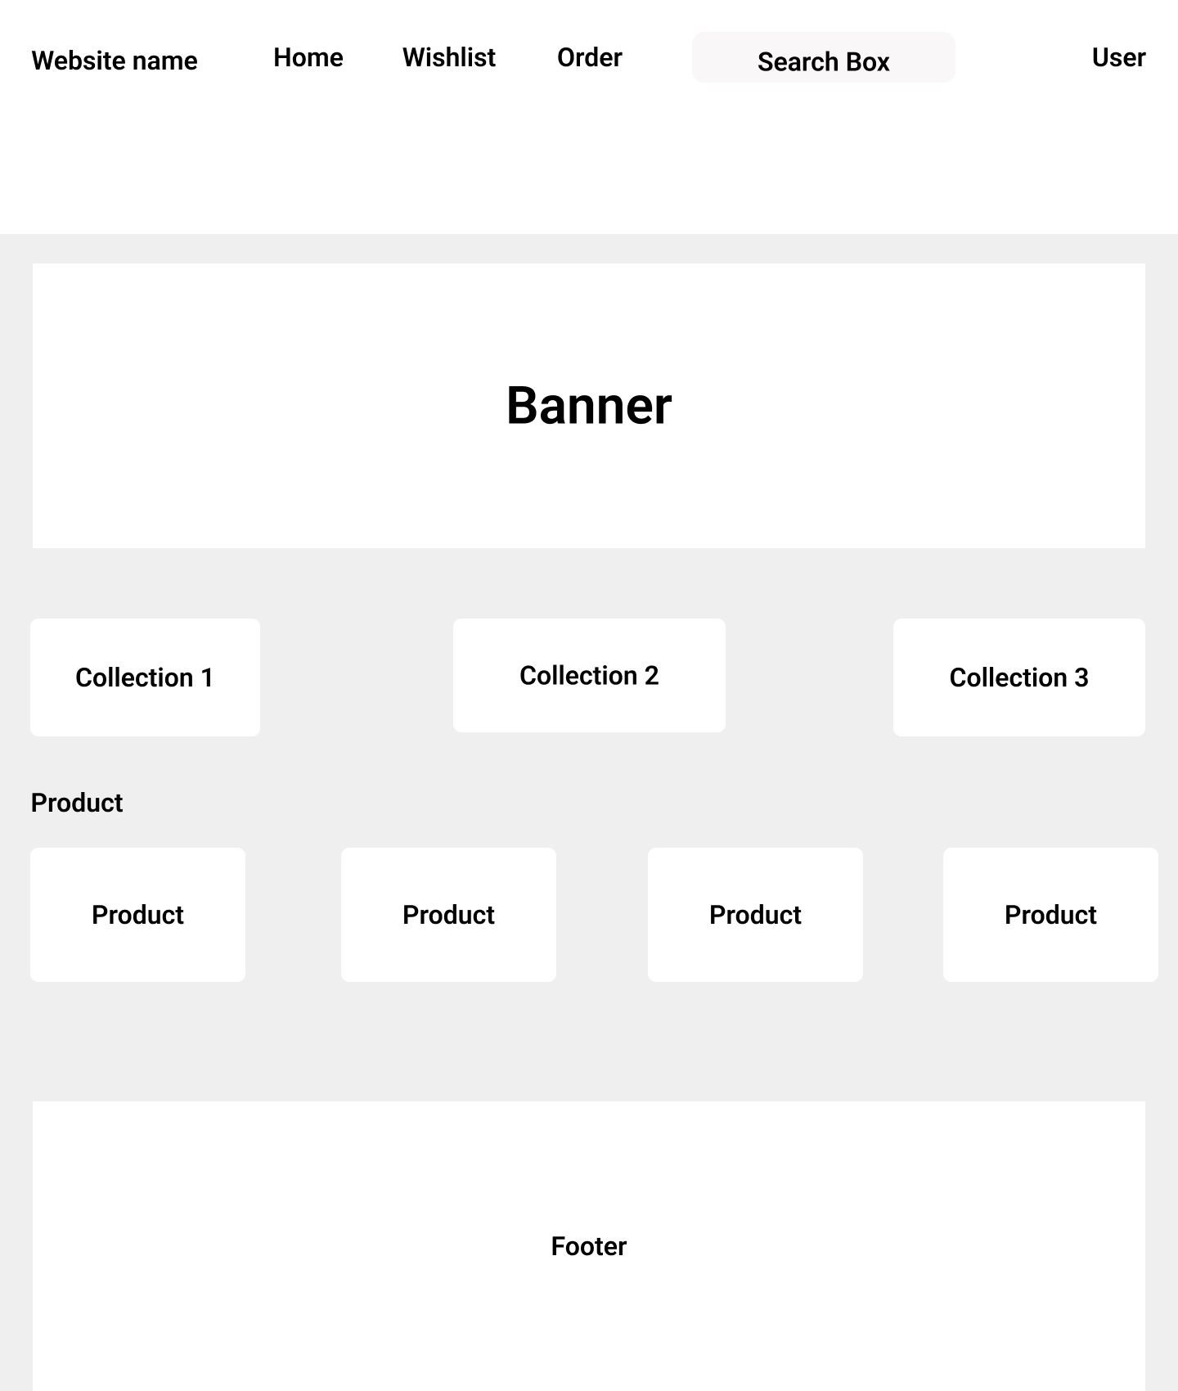
Figure 9. E-commerce Shopping Homepage

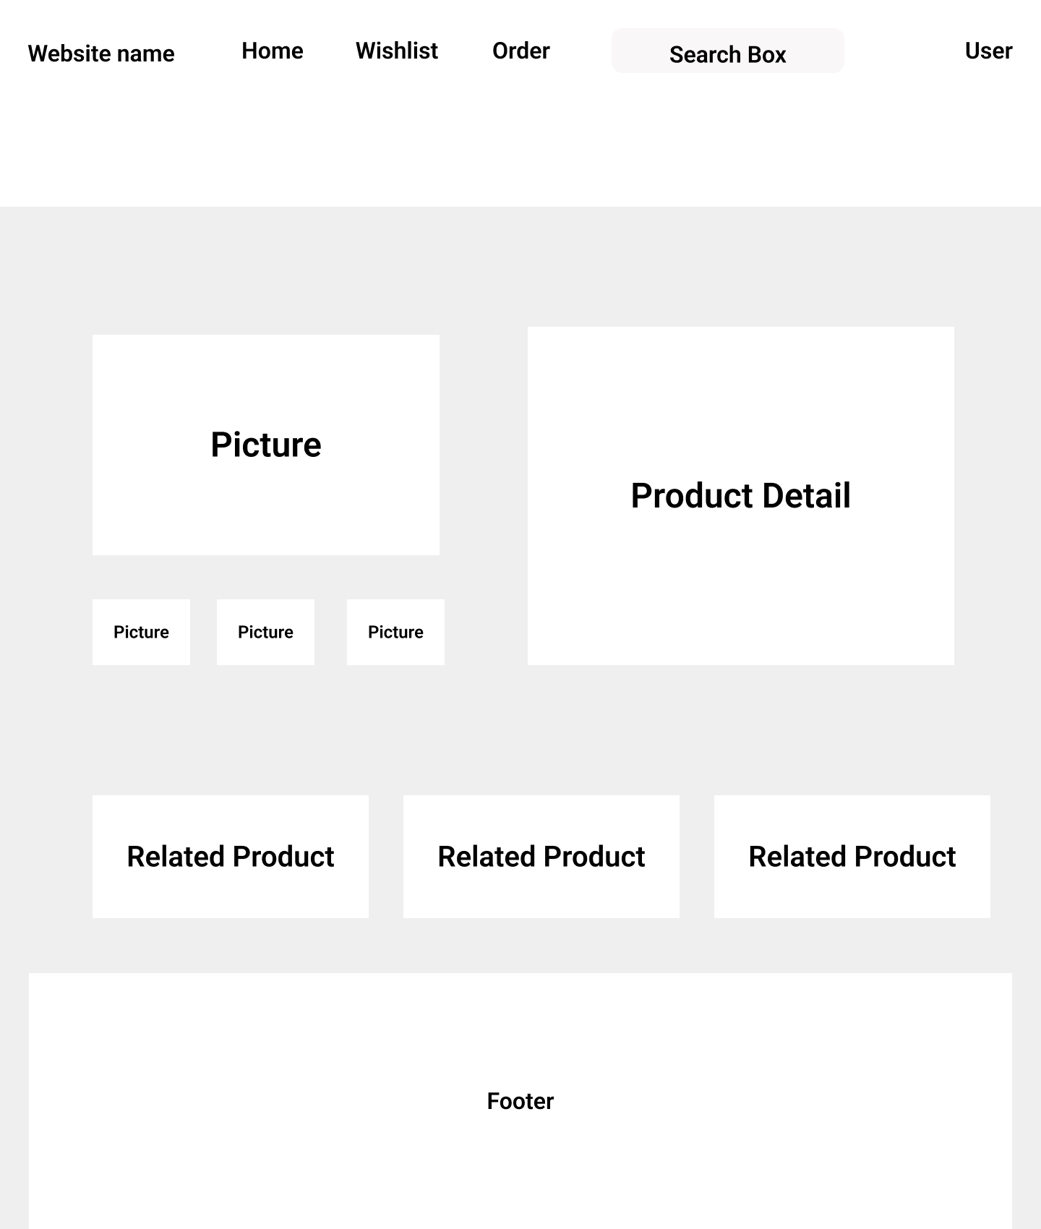
Figure 10. Product Detail Page

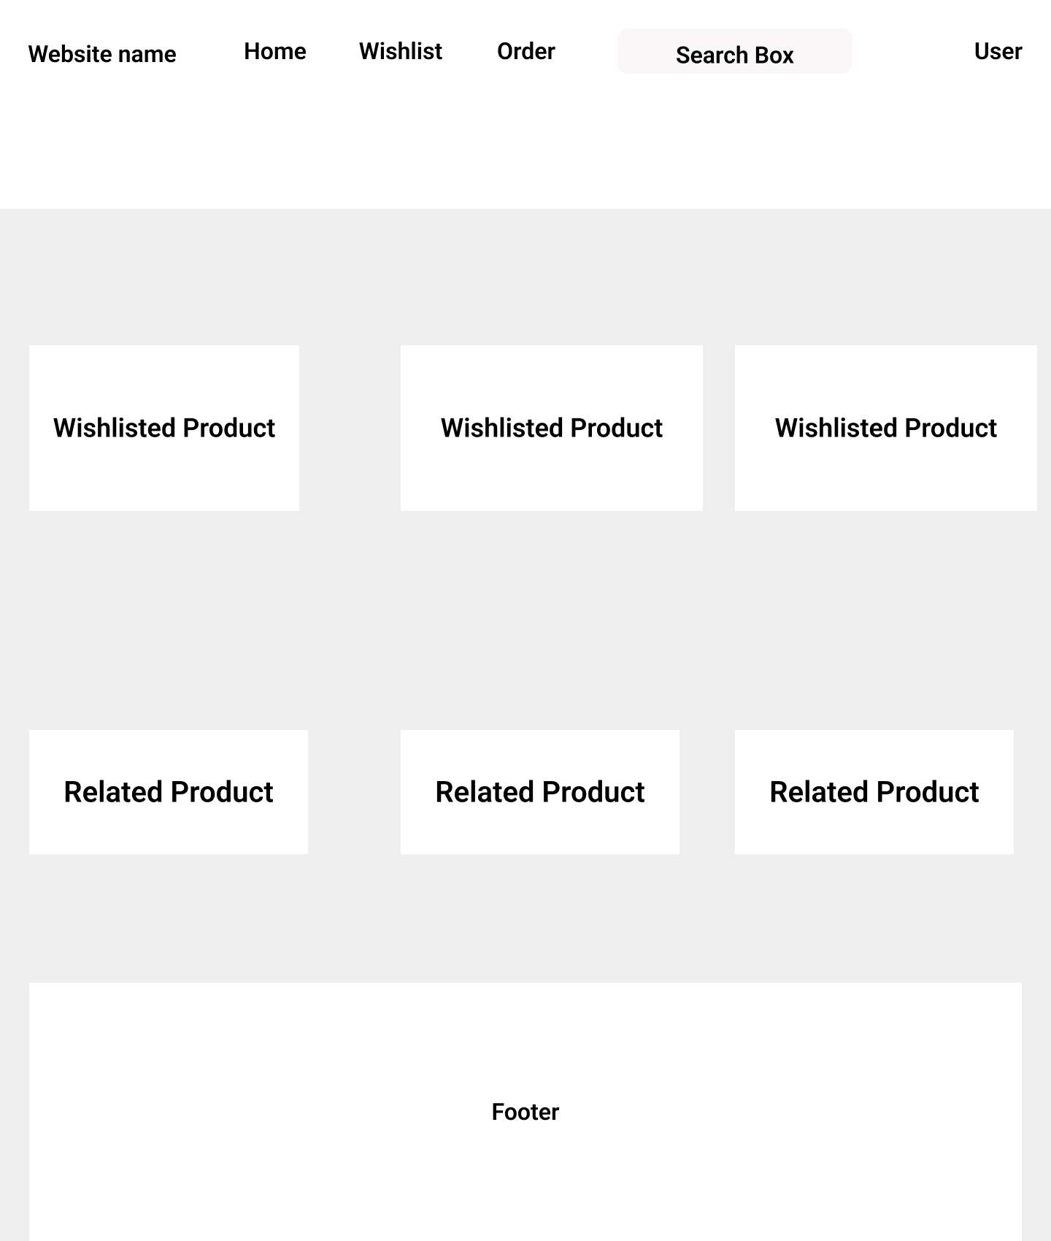
Figure 11. Wishlist Page

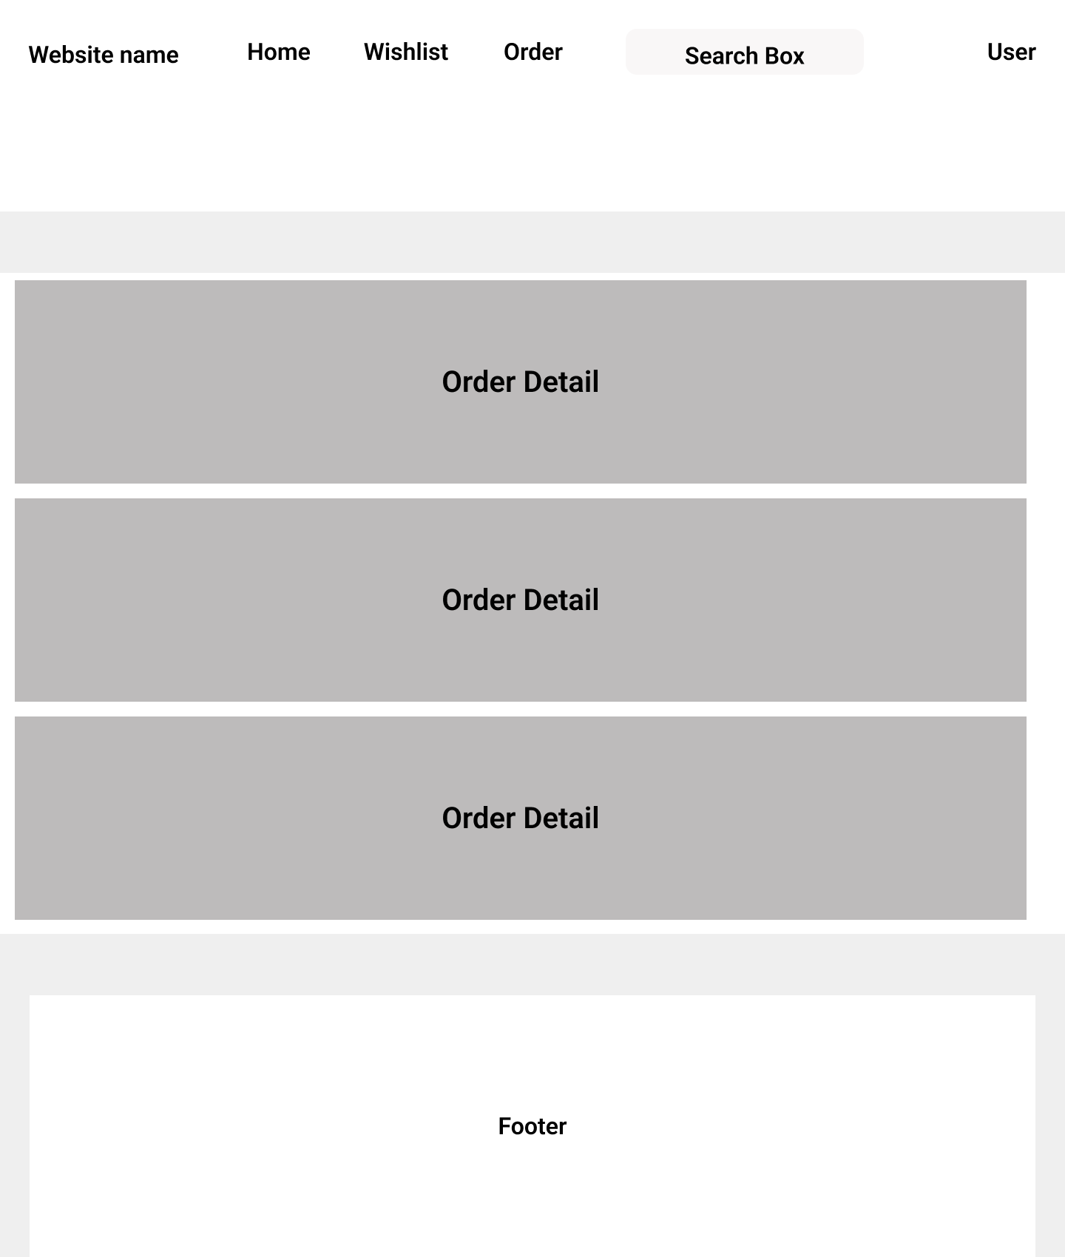
Figure 12. Order Page

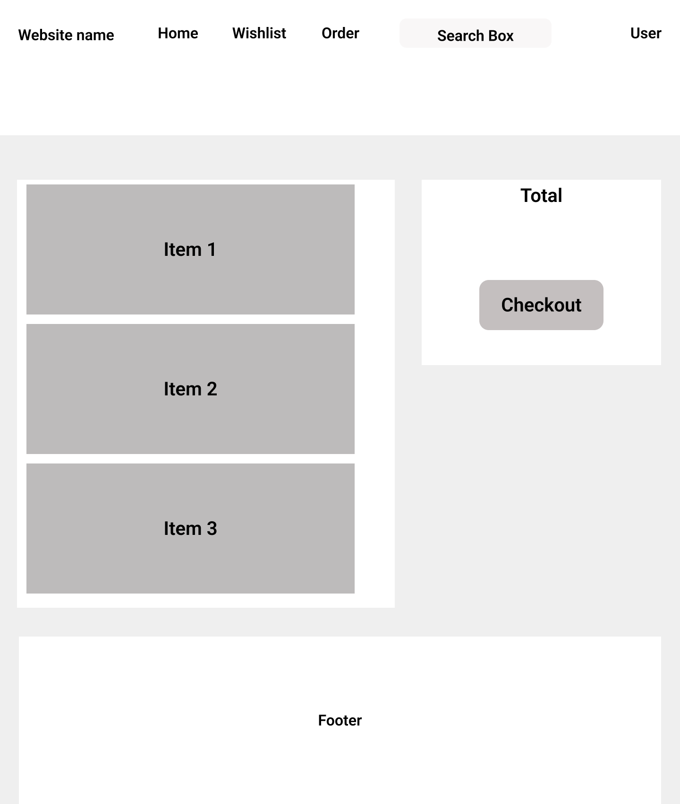
Figure 13. Cart Page

3.3 Database Design

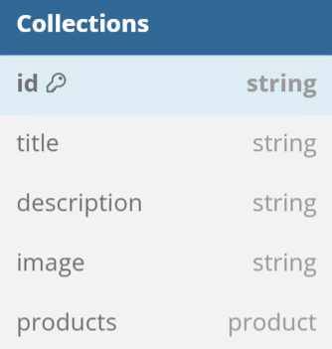
Figure 14. Collections table

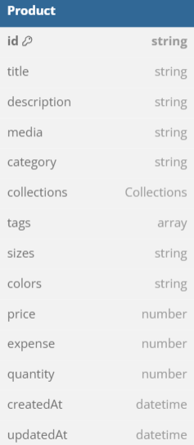
Figure 15. Product table

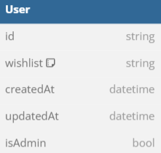
Figure 16. User table

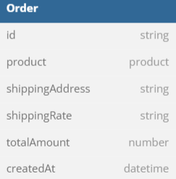
Figure 17. Order table

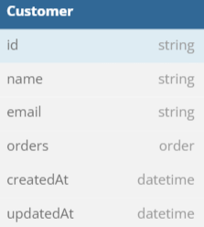
Figure 18. Customer table

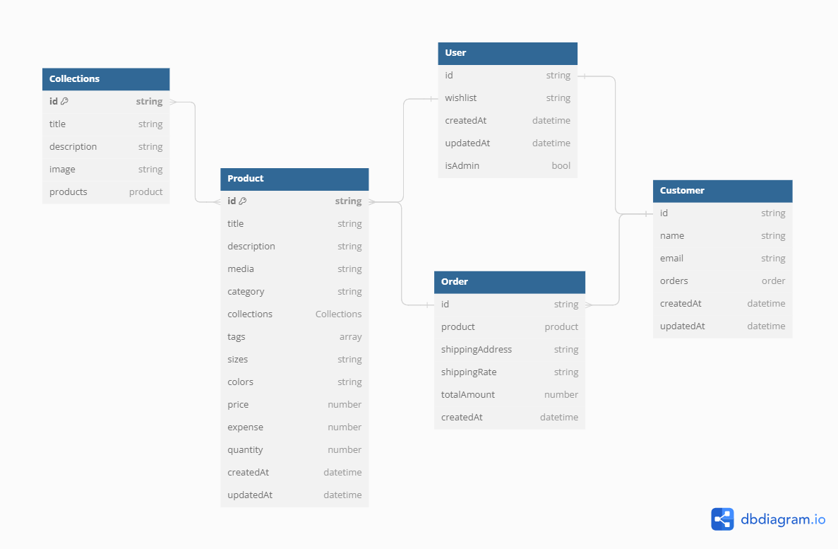
Figure 19. Database diagram

3.4 Implementation

3.4.1 Development environment
The project is developed in the environment as described below:
- OS system: Window 10 lite edition
- IDE: Visual Code
- Database: MongoDB

3.4.2 Implementation
Login page
If a user login successfully, it will access to Home Page when type of the user is “user” and Users Admin Page when type of the user is “admin”^{[1]}.
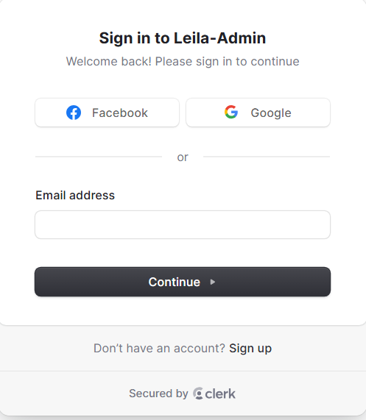
Figure 20. Login page for admin
The login page also includes a username validation mechanism that ensures accuracy before submitting the data to the server. If the entered username is either non-existent or incorrect, the page will promptly display an alert to notify the user.
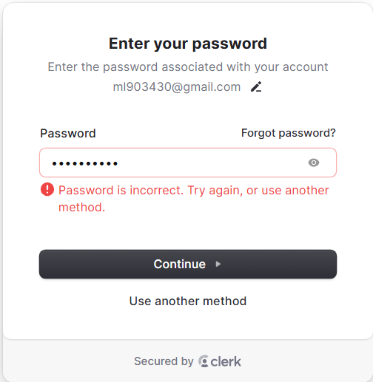
Figure 21. Wrong password warning
Home Page
If a user login successfully, it will access to Home Page when type of the user is “user” and Dashboard when type of the user is “admin”. In this Dashboard, admin can manage collections, products, orders, customers, and view revenue sorted by month^{[1]}.

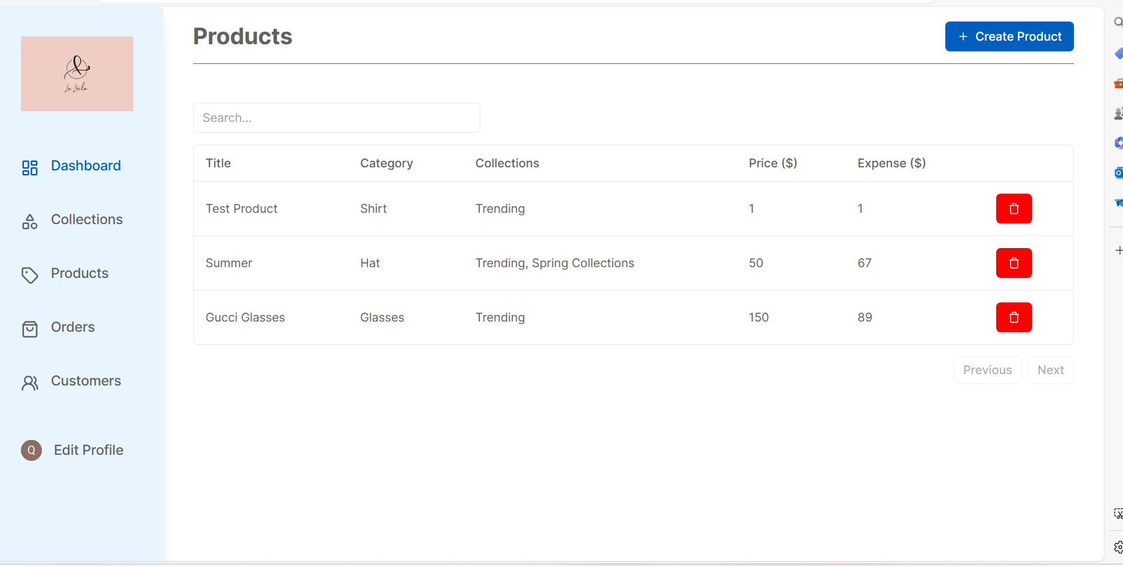
Figure 22. Admin Dashboard


Figure 23. Add or Edit Product

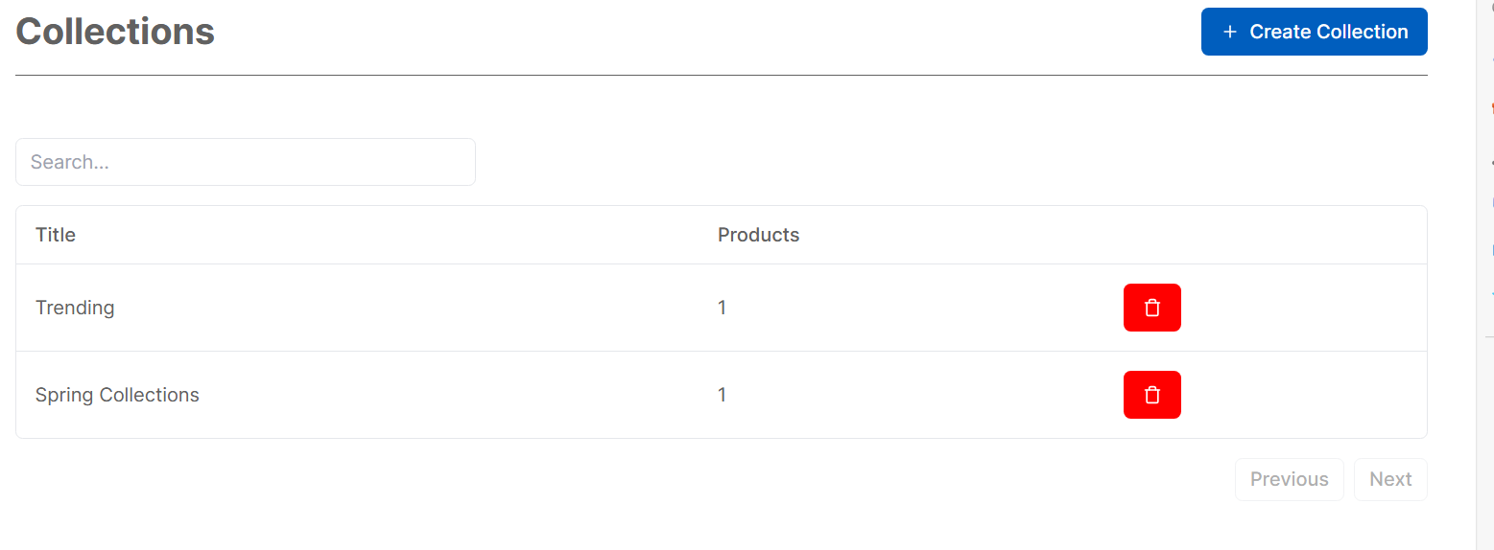
Figure 24. Collection Page

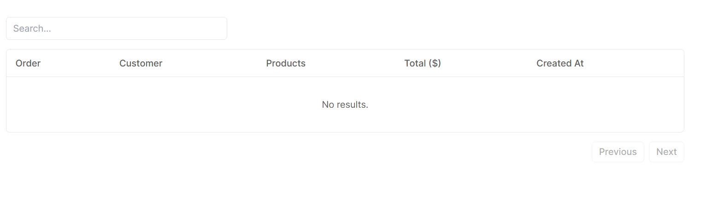
Figure 25. Order Page

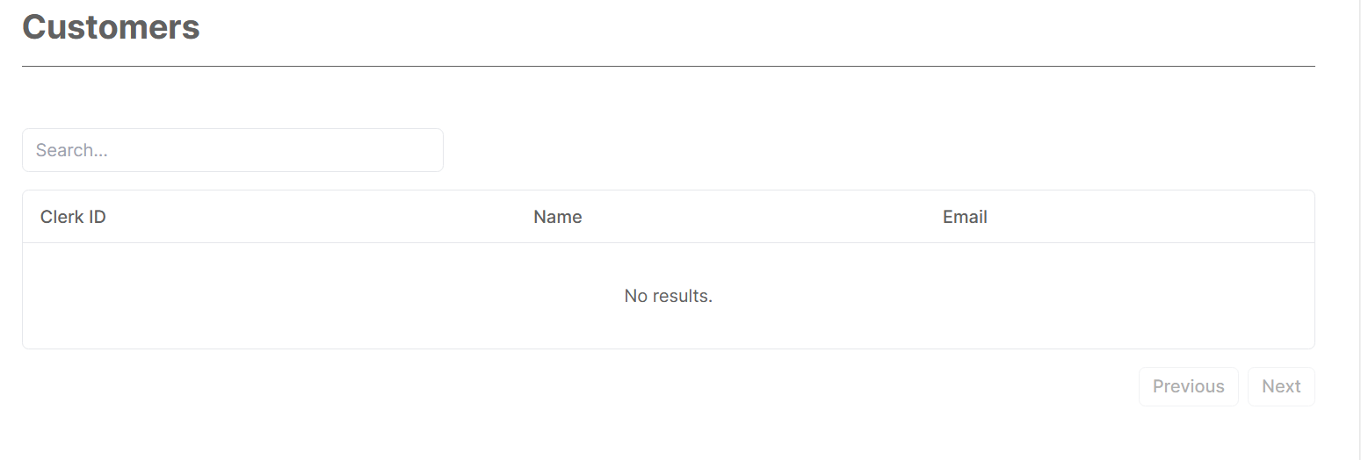
Figure 26. Customer Page

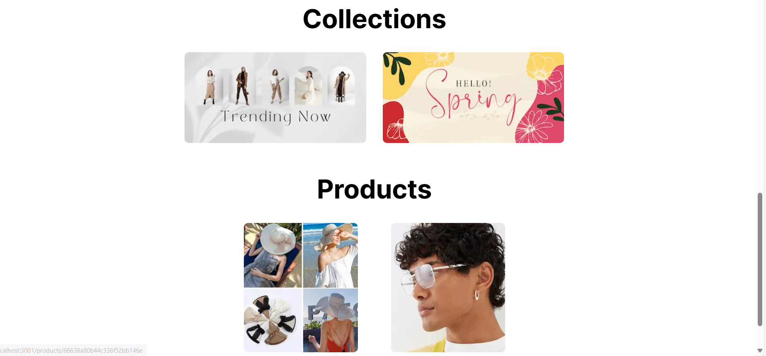
Figure 27. Collection and Product Section

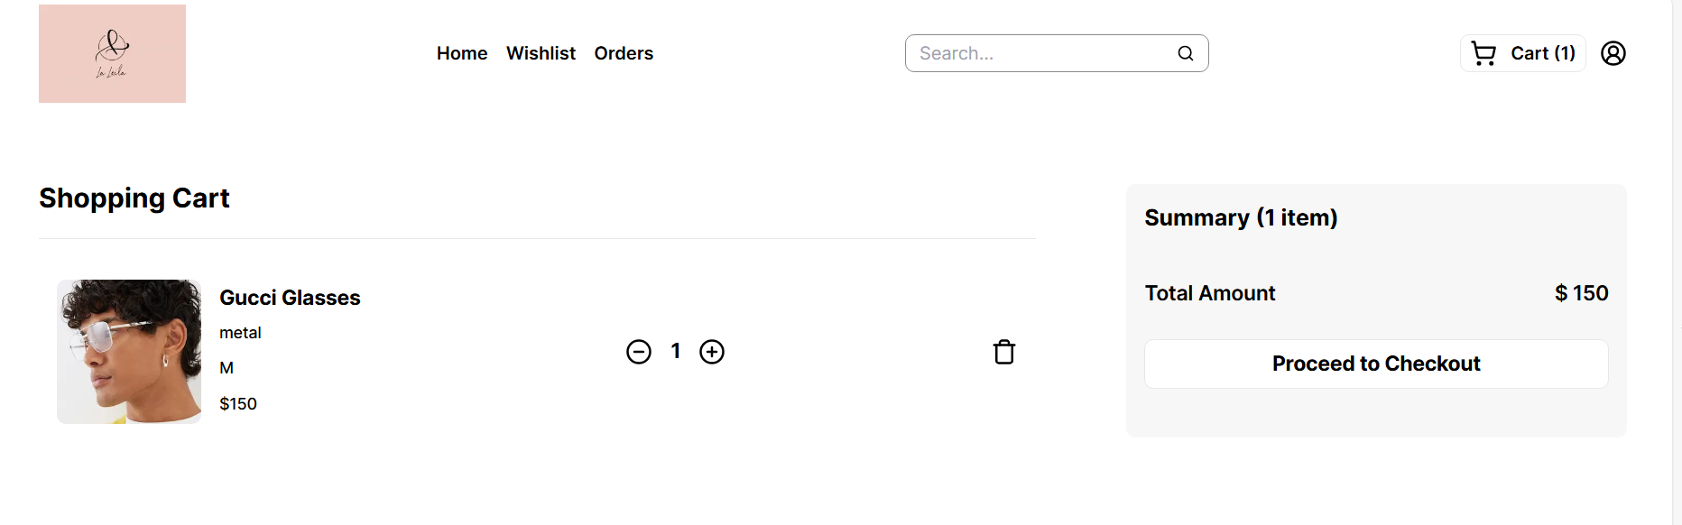
Figure 28. Cart Page

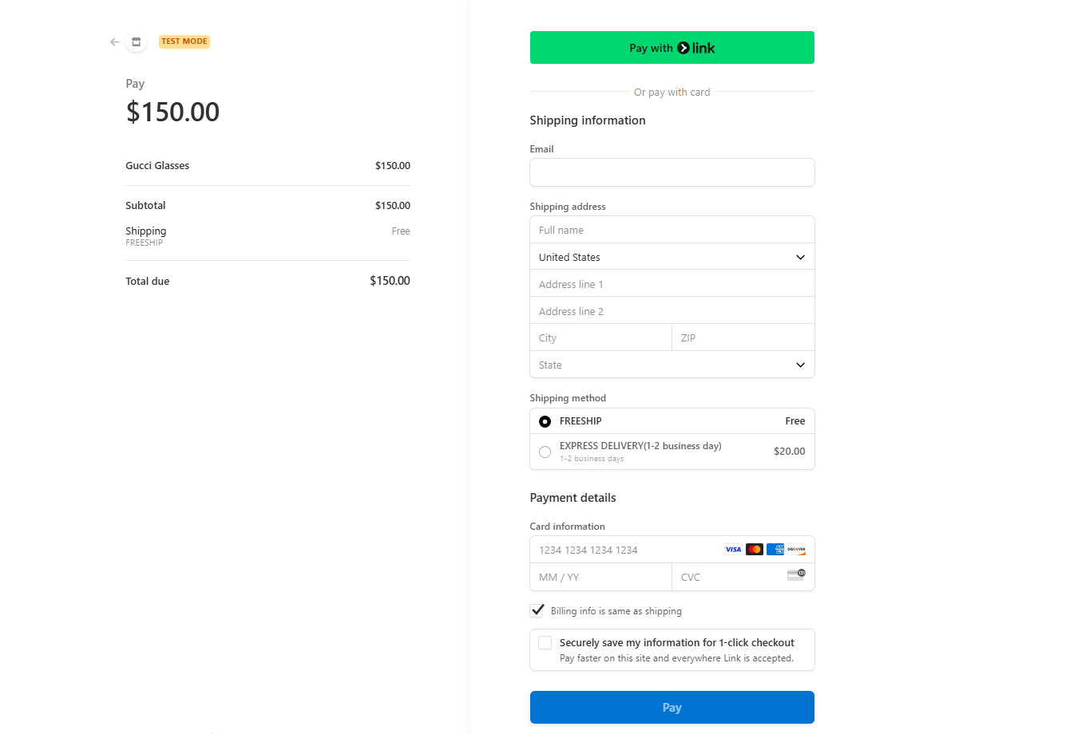
Figure 29. Payment Page

Chapter IV. Result and Discussion
After learning about sales technology at some famous sales websites, I built a "product management application and online shopping website". Successfully built online shopping applications and product management applications partly solve the problem of time and effort in product management, creating conditions for customers to shop more easily.
- The website has provided the following functions according to the original orientation:
+ Register
+ Diary
+ Shopping
- The application has provided basic functions according to the original orientation:
+ Create employee accounts
+ Delete employee accounts
+ Create customer accounts
+ Diary
+ Buy and select products
+ Payment via bank card
+ Search categories
+ Statistical report
+ Usage log

Chapter V. Conclusion and Future Works

5.1 Conclusion
Significant progress has been made in creating a shopping website, including achievements in basic backend functionality and user interface design. However, there are still many notable limitations, especially in terms of functionality and user experience. These have the potential to reduce consumer convenience and satisfaction. These include the lack of advanced search and filtering options Furthermore, delivering a seamless and secure browsing experience is hindered by weak security measures and poor mobile responsiveness. To improve functionality, user experience, and overall competitiveness in the e-commerce sector, these limitations must be addressed in subsequent versions.
Absence of advanced search and filtering options: The website does not yet have this functionality, which might improve user experience by enabling users to filter products based on certain criteria. In particular, vouchers, deals, and suggested products based on interests. Limited payment options: Only simple payment methods are supported by the backend implementation as of right now. Including more payment channels and choices, like PayPal, Apple Pay, or cryptocurrency payments, can increase user convenience and increase the client base.

5.2 Future Works
In the future, we will improve our website by:
- Enhance the user's experience: To improve product discoverability, create robust search and filtering features, such as faceted search and customized filters. Increase the number of gateways and payment options, such as digital wallets, to provide customers additional options. There will be more customer reviews available concurrently with the product.
- Backend improvements: Increased backend capacity for thorough products and customer administration, facilitating better decision-making. Make your website mobile-friendly by optimizing its responsive design and speed. You should also put robust security measures in place, such as secure authentication and encryption, to safeguard user information and ward off online attacks.

REFERENCES
[1] “Installation- Clerk” https://clerk.com/docs/quickstarts/nextjs
[2] M. Krause, The Complete Developer, No Starch Press, 2024.
[3] “Installation - Tailwind CSS.” https://tailwindcss.com/docs/installation (accessed: Jun. 23, 2024).
[4] “What is MongoDB Atlas? - MongoDB Atlas.” https://www.mongodb.com/docs/atlas/ (accessed: Jun. 23, 2024).
[5] “React – A JavaScript library for building user interfaces.” https://legacy.reactjs.org/ (accessed: Jun. 23, 2024).
[6] “What is React.js? Uses, Examples, & More.” https://blog.hubspot.com/website/react-js (accessed: Jun. 23, 2024).
[7] “Building Your Application: Routing | Next.js.” https://nextjs.org/docs/app/building-your-application/routing (accessed: Jun. 23, 2024).
[8] K. Chodorow, MongoDB: The Definitive Guide, O’ Reilly, 2013.
[9] D. Choi, Full-Stack React, TypeScript, and Node, Pack Publishing Ltd, 2020.

